**Brooklyn torah gazette**

**For parshas acharei mos-kedoshim 5781**

Volume 5, Issue 35 (Whole Number 235) 12 Iyar 5781/ April 24, 2021

**Printed L’illuy nishmas Nechama bas R’ Noach, a”h**

For a free subscription, please forward your request to [***keren18@juno.com***](mailto:keren18@juno.com)

Past emails can be found on the website **ShabbosStories.com**

**The Wisdom of Rav Gamliel, Rabbi Blech and the Rebbe**

**By Daniel Keren**

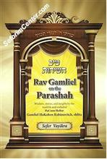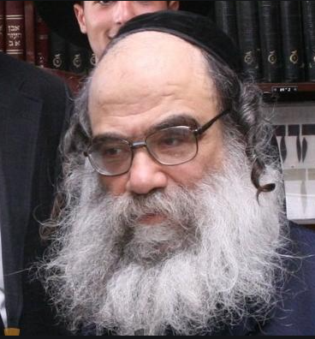

*(Rav Gamliel on the Parashah – Sefer Vayikra: Wisdom, Stories, and Insights by the Tzaddik and Mekubal HaGaon HaRav Gamliel HaKohen Rabinovitch, Shlita, hardcopy, 403 pages, translated by Rav Shmuel Winzelberg)*

In recent years, English-speaking readers have been blessed with the opportunity to access the unique and valuable Torah insights of Rav Gamliel HaKohen Rabinovitch, shlita, a world renowned tzzaddik and mekubal who is the Rosh Yeshiva of Shaar Hashamayim Yeshiva in Yerushalayim as a result of the devoted efforts of Rabbi Shmuel Winzelberg to translate his teacher’s Torah wisdom into English.

In five separate volumes, Rabbi Winzelberg has made accessible to English readers the wisdom, stories and insights of Rav Gamliel on the Chumash; as well as four volumes on the Moadim (Chanukah, Pesach, the Three Weeks and the Yamim Noraim and Sukkot), and five other volumes on the Essence of Chinuch, Emunah, Kibbud Av Va’Eim, Marriage and Tefillah.

**Devoted and Careful Work of the Translator**

I recently purchased Rabbi Winzelberg’s translation of Rav Galmliel Rabinovitch’s insights on Sefer Vayikra insofar as we are reading the parshiots (Torah portions) in this third volume of the Chumash. It is clear that the translator has a deep respect for the Torah teachings of Rav Gamliel and has devoted many hours to try and carefully relay these unique Torah concepts from its original Hebrew lectures.

Rabbi Winzelberg’s efforts have resulted in an enjoyable and easy-to-read sefer that captures the unique flavor of Rav Galmliel’s Torah insights that can be comprehended by any reader ranging from a novice to Torah studies and to a Ben Torah with many years of intense Torah learning.

This volume – *Rav Gamliel on the Parashah – Sefer Vayikra* – can be purchased in Jewish bookstores or from various online outlets. For those readers who are fluent in Hebrew, there are more than 200 shiurim (lectures) of Rav Gamliet Rabinovitch that can be accessed on the popular Torah website – Torahanytime.com

Many times when I am involved in mundane activities like cleaning the house or cooking meals, I utilize Torah websites such as Torahanytime.com to listen or watch fascinating Torah lectures that make otherwise boring duties become more interesting and enjoyable.

**A Chasid in Camouflage**

One of the more enjoyable Torah programs I have recently seen and highly recommend to readers is *A Chasid in Camouflage – Rabbi Benjamin Blech*, a 58-minute video in which Rabbi Blech, a world renowned Modern Orthodox rabbi (longtime rabbi of the Young Israel of Oceanside and professor of Talmud at Yeshiva University) and prolific author of dozens of popular books on various topics of Torah and Judaism discussed his most unusual encounter with the Lubavitcher Rebbe, zt”l (Rabbi Menachem Mendel Schneerson) in 1989.

Just as he was about to enjoy a long-deserved Sabbatical from his teaching duties at Yeshiva University and his rabbinical responsibilities at the Young Israel of Oceanside, Rabbi Blech received a quite unexpected phone call from the office of the Lubavitcher Rebbe in Crown Heights. He was told that the Rebbe wanted to meet Rabbi Blech and that he wanted him to go on a four-month visit to the Far East where he was to deliver inspiring lectures at Chabad Centers.

Rabbi Blech asked if perhaps this was a mistake as he was not a Chasid, but a very Modern Orthodox rabbi. He was told that the Lubavitch headquarters knew everything about him and the Rebbe had not made a mistake in selecting him to go on this special lecture tour.

As a result of the advice the Lubavitcher Rebbe gave him, Rabbi Blech admitted that it changed his outlook on Jewish identity forever, and inspired his philosophy of a Jewish solidarity that disregards our individual differences.

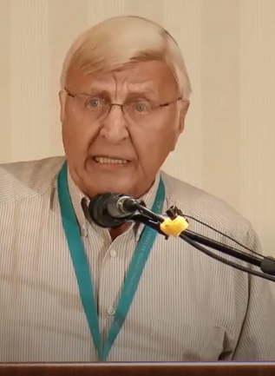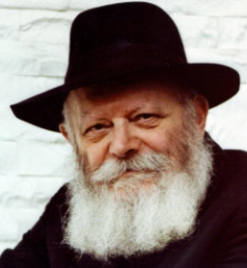

**Rabbi Benjamin Blech and the Lubavitcher Rebbe**

After concluding his lecture tour to Chabad Centers in the Far East, Rabbi Blech made a follow-up visit to inform the Rebbe of what he did had done and what he had observed. The Rebbe in addition to telling Rabbi Blech that he saw him as a **Chasid in Camouflage** asked his “unusual” chasid if there was any way he could help Rabbi Blech. Rabbi Blech brought up the fact that he had a daughter who was getting a little older and requested a brocha (blessing) that she should find her bashert (husband.) To find out how that brocha worked out, why not google – A Chasid in Camouflage – Rabbi Benjamin Blech.

*Reprinted from the April 16, 2021 edition of The Jewish Connection.*

# Rav Avigdor Miller on

# Being Kind Hearted to Gentiles



**QUESTION: Is it permitted to hate goyim?**

**ANSWER:** Now that, you have to know, is a question that never comes up among Jews.  Jews never talk about hating goyim.  And I’ll explain that.

It’s true that there’s a mitzvah of ואהבת לרעך כמוך – you have to love your fellow Jew.  It means that there’s no command to love somebody who is a non-Jew.  To love non-Jews, there’s no mitzvah at all. But certainly nobody is told to hate anybody! Because hate is a boomerang. You just cannot hate and hate and hate without become a hateful person.  Your nature changes.

If a person is always muttering imprecations on goyim for nothing, then he becomes a low character.

Decent Jews are kind hearted and polite to everybody!  אמרו עליו על רבן יוחנן בן זכאי שלא הקדימו אדם שלום מעולם – It was said about Rabbi Yochanan ben Zakai that nobody ever said shalom to him in the street before he said shalom to them.  He was the first one to greet a man.  ואפילו נכרי בשוק – even gentiles in the street; when he encountered a gentile, he was the first one to greet him.  That’s politeness. That’s how a Jew behaves.

The Chofetz Chaim was like that. In Radin, there were very small sidewalks – there wasn’t enough room for two people to walk side by side and so whenever somebody was walking on the sidewalk, he walked off the sidewalk to let the person walk. He yielded the sidewalk.

Once he was walking and a Russian general was passing by and the Chofetz Chaim yielded the sidewalk.  So the Russian general said, “Old man, why are you yielding to me? You’re yielding the sidewalk to me, a young person?”

So the Chofetz Chaim said, “I do it to everybody.”

So the general said, “You’re going to live long,” he said.  “You’ll live long because of that.” That’s a blessing from a Russian general.

The truth is that Jews are always kind hearted to everybody; only that the mitzvah of loving a Jew is a specific mitzvah that’s only for fellow Jews. You don’t have that mitzvah for anybody else.

But to be kind and polite, that’s not even a question. It’s not an issur of lo sechanem. Lo sechanem means to do favors for nothing; that you don’t do. However, for your own benefit, favors for your own character you can do.  And anything you do for gentiles that improves your character, it’s a good thing to do because you’re doing it for yourself.

*Reprinted from the April 11, 2021 email of Toras Avigdor. Adapted from Tape #680.*

**Rabbi Berel Wein on**

**Parshat Acharei Mot-Kedoshim 5781**

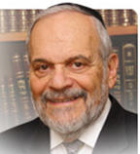

The Torah reading for this week is a double portion, which together contains the largest number of commandments that appears in any one section of the holy Torah. One question which has challenged Judaism throughout the ages is why do we need so many commandments to fulfill our obligation to be good, kind, and faithful? Is it not sufficient that we understand the general principles as outlined in the Ten Commandments, which permeate all Jewish life and scholarship?

**The Devil is in the Details**

Since we are aware of the goal – namely that of being a good, honest, and compassionate human being – shouldn’t that realization suffice and not require all of the particular details that make up the bulk of this week’s Torah reading. Even though we understand, as any lawyer will tell you, that the devil is in the details, at first glance and even with a superficial understanding, it seems completely superfluous to have these many instructions hurled upon us, to achieve the goal that we are all aware of.

By the way, this has always been the contention of some factions in Jewish life through history - that the details of the commandments were not really that important, but as a Jew, it was crucial to be a good person at heart. This was the contention of the ancient Sadducees in second Temple times and continues to be the philosophy of all those groups that deviated from Jewish tradition and observance of the Torah Commandments throughout the ages.

It remains, even today, the banner of the non-Orthodox groups that loudly proclaim and justify their essential non-Jewish Jewishness. To them, the details are unnecessary, burdensome and of little value. Just be a good person, they proclaim, and that alone is the essence of Judaism.

**The Road to Hell is Paved with Good Intentions**

But human history teaches us differently. As has been famously articulated: the road to hell is paved with good intentions, and good intentions often lead to tyranny over others, and even to murder and genocide. Without the details, how are good intentions to be fulfilled. We cannot rely upon human judgment to guarantee that those good intentions will ever be realized.

The worst dictators and murders of the past few centuries such as Napoleon, the Kaiser, and even Hitler and Stalin always proclaimed that they had good intentions for their country, and, in fact, for all of mankind.  They maintained that to achieve those good intentions they were entitled to use force and coercion against millions of others, to actualize their good objectives.

In our current world society, good intentions alone, without the restraint of the commandments and details, led to the murder of millions of unborn but living fetuses, concentration camps, gulags, the cancel culture, and the tyranny of the majority over the minority, no matter how slight the margin of majority in terms of numbers and popularity.

**Good Intentions Can be a Danger**

**If Not Controlled Properly**

Good intentions without the restraint of details and commandments are, in fact, a danger, and not a boon to human society. Through the Torah commandments, Judaism offers instructions as how to become a good person and maintain a moral life. It teaches us that oftentimes it is the minority, not the majority, that is correct.

Even though the goal of being a good and holy person should never be forgotten – for otherwise the observance of the details would be of little value, as is noted by Ramban, that one can be a wicked person while believing oneself to be within the purview of the Torah. It is the balance between the great ultimate goals and the details of how to achieve that. which makes Judaism unique, vibrant, and eternal. This balancing act is the secret of the survival of Judaism and the Jewish people throughout the ages.

*Reprinted from the current website of Rabbiwein.com*

**Parshas Acharei Mos**

**Systems of Human Perfection**

**By Rabbi Bentzion Shafier**

**Founder of TheSmuz.com**

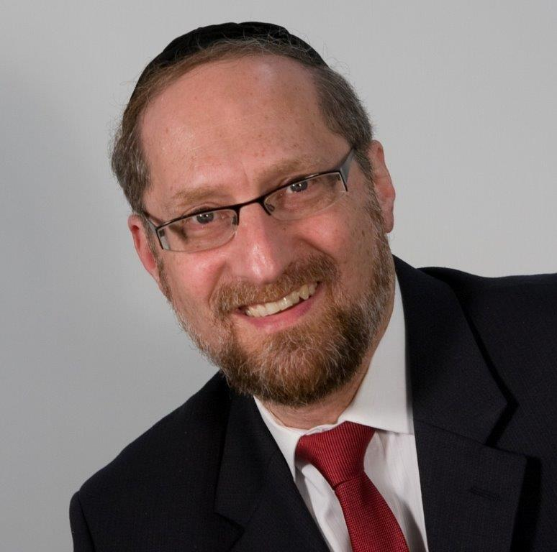

“*And a man from the house of Israel, and from the converts who live with you, who shall consume any blood, I shall place My face against the soul of the one who consumed blood, and I shall cut it off from amongst your nation*.” Vayikrah” 17: 10

The Torah warns us many times and with many different exhortations not to consume blood. The Kli Yakar points out than in Devarim the Torah tells us not to eat blood because “It will be good for you and your children after you”. He explains that: “Consuming blood brings cruelty into the one who eats it, and the nature of the father is given over to his children to be like him. Therefore, the Torah warns us not to consume blood so that we don’t acquire this nature.”

It seems clear from the Kli Yakar that consuming blood will cause a change in the nature of the person who consumes it. His sensitivities and reactions will have changed, and he will become a different person. However, not only will he become callous and pitiless, these traits will become part of his genetic transmission, so that any child that he then has will have this same predisposition towards cruelty.

This concept seems difficult to understand. Firstly, how does consuming blood make a person cruel? Secondly, how does that change affect the very hereditary transmission of a person so that his children will be pitiless as well?

To understand the answer to this, we need to focus on the basic make-up of man.

The Chovos Ha’Levovos (Sha’ar Avodas Elokim 3) explains that HASHEM created man out of two very distinct parts – a nefesh ha’Schili (intellectual soul) and a nefesh Ha’Bahami (animal soul). The “I” that thinks, feels, and remembers is comprised of two separate and competing parts, each one with its own nature, tendencies, and needs. The nefesh ha’Schili desires only that which is good, right, and noble. It yearns to help others, it hungers for meaning and purpose, and more than anything, it needs to be close to HASHEM.

Then there is the other part of man — the animal soul. It too has desires and inclinations, and it too hungers for things. One way to better understand the animal soul in man is to visit its parallel in the wild kingdom.

**Understanding the Nefesh Ha’Bahami**

HASHEM imprinted into the essence of each animal all the instincts necessary for its survival as well as for the continuation of its species. The animal doesn’t have a cognitive, reasoning element. It doesn’t have an “I” that is the master of the ship. But it does have a vibrant essence that is programmed to seek out its needs. That part is the nefesh of the animal.

That nefesh is pure instinct, drives, and passions, and is affected by both internal and external triggers. In the spring, birds fly north and engage in a fury of nest-building and mating. The individual bird doesn’t purposefully choose its mate. Two robins don’t sit down and say to each other, “It’s time for us to settle down and raise a family.” The animal is attracted by the sight, smell, and sound of one of its species, and then will hotly pursue it – often becoming bonded for life. It is driven by instinct in a preset pattern.

Those instincts and desires are affected by various forces. A bird from a different species will not elicit the mating response, nor will even the same bird in a different time of the year. In the dead of winter, these desires lay dormant. The change in season brings them forward to the extent that they take over the existence of that bird. They have been pre-programmed to respond to stimuli that allow for the success of the individual bird and the species as a whole.

**The Answer to the Kli Yakar**

This seems to be the answer to the question. The Kli Yakir is teaching us that when the Torah forbids us to eat blood, it is because consuming it would make a dramatic change in our inner essence. We would be ingesting part of the nefesh of that animal, and it would become part of our own Nefesh Ha’Bahami. Our conscious reality would change because part of who we are is the animal soul, and we would thereby acquire cruelty. This change is so potent that if the person who drank that blood were to then have a child, that child would also have cruelty as part of his inner make-up.

Much like certain chemicals can affect a man’s mood; the Torah is teaching us that there are some properties that have a permanent effect on the nature of man. They change his Nefesh, and that changes the way that he thinks and feels.

Similarly, the mefarshim explain to us that none of the kosher animals are predators. The nature of a predatory animal is to hunt down and kill. If a person were to consume meat from such an animal, some part of the Nefesh of that animal would enter into man’s soul and he would acquire an aggressive, violent nature. The Torah forbids it because it would damage the fine balance in man.

This concept is very significant as it helps us better understand the Torah as the system of human perfection. HASHEM is the Creator, and He wrote the Torah as the guidebook for human growth. Contained within it are all the tools necessary to reach greatness. Some of the tools are easily understood and some takes years to fully comprehend, but the system is there. By following the guidelines, restrictions, and commandments, a person guarantees that he is headed in the right path – using his stay on the planet to grow and perfect himself.

*Reprinted from the website of Theshmuz.com.*

**The Jew’s Obligation to Continually Emulate G-d**

**In Striving to be Holy**

**From the Talks of the Lubavitcher Rebbe**

**Rabbi Menachem Mendel Schneerson, Zt”l**

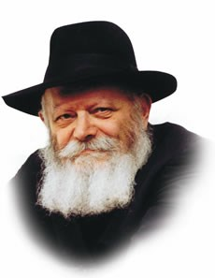

The two Torah portions that are read this week, Acharei and Kedoshim, share a common theme: holiness.

Acharei begins with a description of the most sacred service performed throughout the year: the Yom Kippur service, rendered by the High Priest in the Holy of Holies.

Yom Kippur is the holiest day of the year, the Holy of Holies the most sacred place on earth, and the High Priest the embodiment of the highest spiritual level a Jew can attain.

**A Jew Must be Holy Because G-d is Holy**

Similarly, the second Torah portion, Kedoshim, begins with the commandment, "You shall be holy because I am holy."

How are we supposed to attain such elevated levels of holiness?

The answer lies in the above-quoted words: "Because I am holy." Because G-d is holy, and because every Jew possesses a Jewish soul, a "veritable part of G-d above," not only is holiness within our reach, but making sure that holiness is manifested in our daily lives is the obligation of every Jew.

The literal meaning of the word "acharei" is "after."

"And G-d spoke to Moses after the death of the two sons of Aaron, when they came near before G-d and died." Aaron's sons Nadav and Avihu were so desirous of cleaving to G-d that their physical bodies became superfluous; consequently, their souls left their bodies.

However, lest we conclude that attaining such an elevated state of holiness is the ultimate objective, after which there is nothing left to do, the word "acharei" comes to remind us that there is much work for the Jew even after he has reached the highest of spiritual levels.

**A Jew Must Never be Static**

A Jew is never static; he must always strive upward, no matter how much he has already attained. There's always a higher rung on the ladder, another way of introducing sanctity into his daily existence.

From where do we get this power?

From G-d's command: "You shall be holy because I am holy." G-d's holiness is unlimited and boundless; no matter how sanctified a human being may be, there's always a higher level he can aim for.

This, then, is the lesson to be derived from this week's Torah reading: We must never be satisfied with our present spiritual attainments, but must always endeavor to attain ever-increasing levels of G-dliness and sanctity.

*Adapted from Likutei Sichot of the Rebbe, Vol. 12*

*Reprinted from the 5756/1996 Acharei Mos-Kedoshim edition of L’Chaim Weekly. Adapted from Likutei Sichot of the [Lubavitcher] Rebbe, Vol. 12.*

**Prince Philip’s Mother Saved Jews during the Holocaust**

**By**[**Adam Ross**](https://www.aish.com/authors/500347332.html)

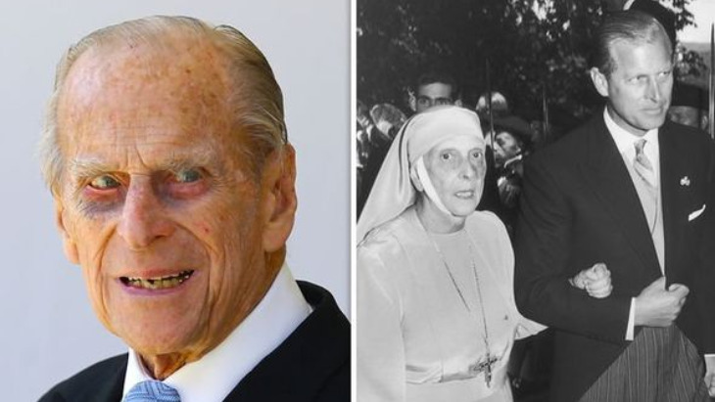

***Husband to the Queen for 74 years, Prince Philip was deeply proud of his mother, Princess Alice of Greece who was recognized as one of the Righteous Among the Nations.***

"I suspect that it never occurred to her that her action was in any way special," Prince Philip, the Duke of Edinburgh, once said about his mother, [Princess Alice of Greece](https://www.aish.com/ci/s/Princess-Alice-and-the-Jews.html), who rescued a family of Jews during the Shoah. "She was a person with deep religious faith and she would have considered it to be a totally human action to fellow human beings in distress."

Prince Philip died on Friday, aged 99, he had been married to Queen Elizabeth for 74 years.

**Princess Alice**

Born at Windsor Castle in 1885, a granddaughter of Queen Victoria, Princess Alice was diagnosed with deafness at a young age and by the age of eight had learned to lip read fluently. Known for her sensitivity to others, enhanced by her own disability, she was married to Prince Andrew of the Greek-Danish Royal family. During the Second World War, the southern part of Greece was occupied from 1941, with the north also occupied from 1943.

*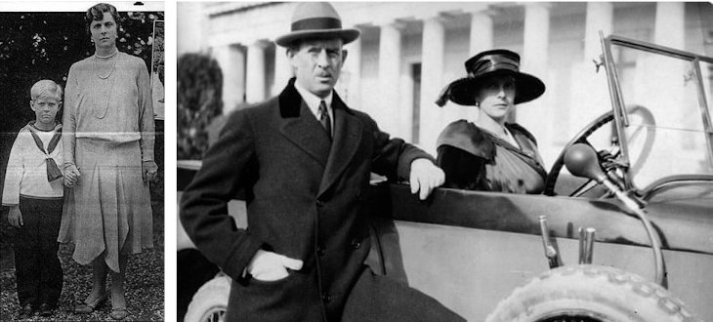****(Left) Princess Alice with her son Philip, (Right) Princess Alice and Prince Andrew.***

The Nazis began deporting Jews from the south to death camps in Poland in 1942. Haimaki Cohen had been a Jewish member of the Greek parliament and was known to Princess Alice. He died in 1943, having fled to the north of the country. His wife Rachel and her family were hidden by a three sisters on the outskirts of Athens, but had to flee after a short period of time.

Princess Alice who had been assisting the Swedish and Swiss Red Cross to help care for refugees, heard of the Cohen’s plight and opened the doors of the palace to them. Three of Rachel’s grown up children succeeded in escaping Greece, reaching Egypt via Turkey, while Princess Alice sheltered Rachel Cohen and her daughter Tilde in a third-floor apartment in the palace.

The Cohens remained in the palace for 13 months, with the princess regularly visiting and talking at length with Rachel, also assigning the family two Greeks who helped the family keep in contact with the outside world. It was this communication which helped Rachel discover that one of her sons had not been able to reach Egypt. He was also brought to the palace joining his mother and sister.

Helping a Jewish family came with great risks, especially for Princess Alice, since three of her four daughters had married German princes, who were serving as SS officers. Suspicions of her loyalty were rife, since Philip, her only son had much earlier enlisted to the British Royal navy at aged 18 where he served throughout the war with distinction.

*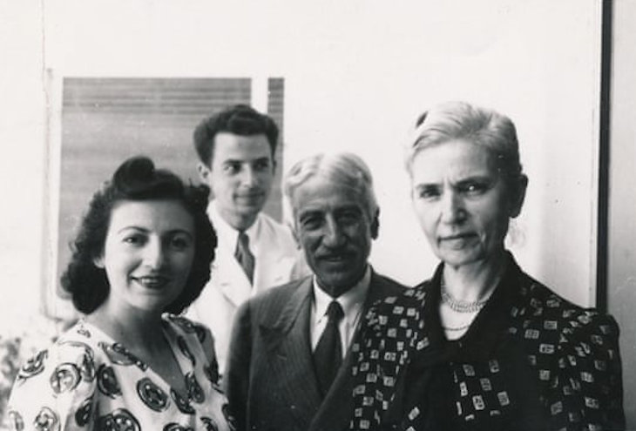****The Cohen family,Left to right, Tilde Cohen, Alfred Cohen, Haimaki Cohen and Rachel Cohen in 1941. Photograph: Evy Cohen***

At one point Gestapo officials visited her Athens home and were suspicious of who was living upstairs. The princess played up her deafness, pretending not to comprehend their questioning and claiming simply that a nanny lived with her.

The vast majority of Greece’s approximately 80,000 Jews were murdered in the Holocaust.

Princess Alice established a convent in Athens dedicated to helping the needy. Following a coup in the country, she returned to Great Britain to be near to her son and his wife the Queen, whom she lived with at Buckingham Palace, dedicating herself solely to helping the disadvantaged and needy.

Shortly before her death in 1969, Alice requested to be buried in Jerusalem on the Mount of Olives. She died without any possessions having given everything she owned away. 19 years later in 1988, in accordance with her wishes, her body was flown to Israel and placed in the crypt in the Garden of Mount Gethsemane on the Mount of Olives.

In 1990, the Cohen family formally applied for [Princess Alice](https://www.aish.com/sp/so/Queen-Elizabeths-Mother-in-Law-Saved-Jews-during-the-Holocaust.html) to be recognized as one of the Righteous Among the Nations, and in 1994 Prince Philip made a private visit to Israel to plant a tree in his mother’s memory. He was a guest of the President of Israel, Ezer Weitzman, visited his mother’s tomb and spent time speaking with the Cohen family and their descendants who owed their lives to his mother’s kindness.

*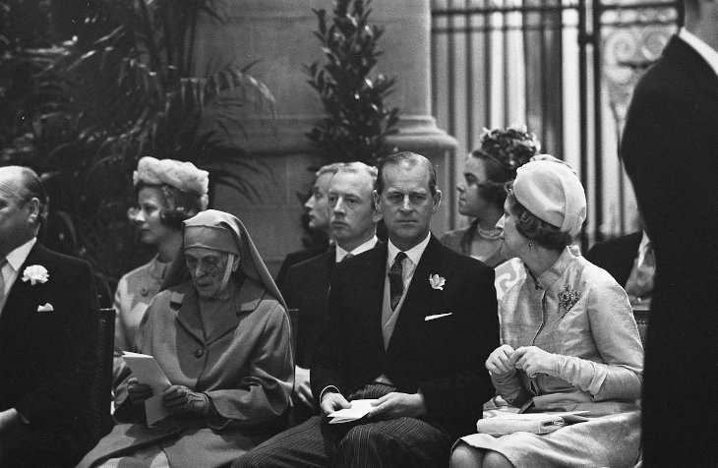****Attending a wedding in 1957 Prince Philip, Duke of Edinburgh, with the Queen to his right and his mother Princess Alice to his left.***

Speaking at the ceremony Philip said his mother had acted purely out of faith and conscience. “For years, we did not know, and, as far as we know, she also never mentioned to anyone, that she had given refuge to the Cohen family.”

Prince Philip also added his own recollection of Nazi antisemitism while studying at a boarding school as a 12-year-old boy, in the town of Salem in Southern Germany as Hitler rose to power. The school had been owned by one of his brothers-in-law.

*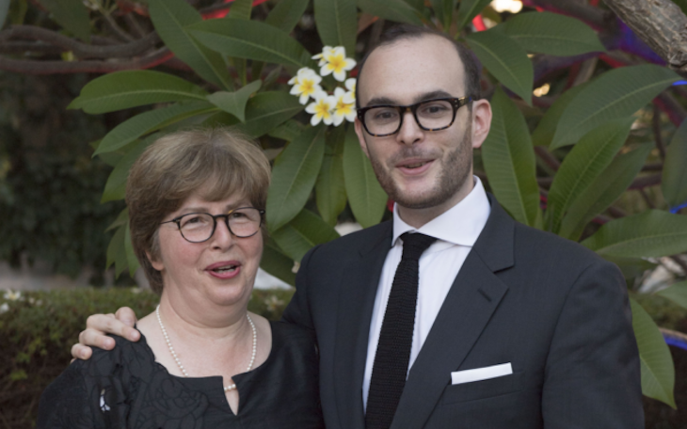Evy Cohen and Philippe Cohen, descendants of Rachel Cohen who was given refuge by Princess Alice of Greece.*

“It was the custom of the school to appoint a senior boy to look after the new arrivals. I was unaware of it at the time, but it so happened that our 'Helper', as he was called, was of Jewish origin. One night he was over-powered in his bed and had all his hair cut off. You can imagine what an effect this had on us junior boys. Nothing could have given us a clearer indication of the meaning of persecution."

Phillip had played cricket for his school in England, and still owned his cricket cap which he offered to the Jewish boy to cover his shame. “I was pleased to see that he wore it.”

In 2018, Prince Philip’s grandson, Prince William, currently second in line to the throne, visited Israel on the first official state visit, paying his respects at his great grandmother’s tomb and also meeting Evy Cohen, a granddaughter of Rachel Cohen, along with her little cousin Philippe.

Evy Cohen said, “It was very moving, for all sides. Prince William was very proud to know that his great-grandmother had saved our whole family.”

Philippe told the prince, “We all owe our existence to the courage of Princess Alice. Her attitude was extraordinary, and what she did was absolutely extraordinary. She was very courageous and risked her own life to take in a family in need.”

*Reprinted from the April 11, 2021 email of Aish.com*